**WOX7001 RESEARCH METHODOLOGY 1/2022/2023**

____________________________________

**Optimizing Blended Learning for Malaysia Higher Education Students: Exploring the Optimal Blend for Engagement and Learning Outcomes  
____________________________________________________**

**ASSIGNMENT 1**

|  |  |
| --- | --- |
| Matric Number : | S2180377 |
| Name : | Tang Ying Ming |

**Table of Contents**

1.Abstract.................................................................................................................................. 1

2. Introduction (Research Background) ................................................................................... 2-4

3. Research Problem Statement ................................................................................................ 4-5

4. Research Questions .............................................................................................................. 5

5. Research Objectives ............................................................................................................. 6

6. Research Scope and Contribution ........................................................................................ 6-7

7. Reference List ...................................................................................................................... 8

**Abstract**

One potential educational strategy that makes use of both traditional and digital learning environments is blended learning, which mixes online and in-person instruction. For educators and instructional designers, finding the ideal balance between online and face-to-face learning still poses a significant problem. By examining the factors influencing the blend, analysing the effects of various instructional ratios on student engagement and learning outcomes, and offering evidence-based recommendations for designing and implementing efficient blended learning models, this research seeks to close this knowledge gap.

A mixed-methods research strategy was used to gather qualitative data from educators and administrators with blended learning expertise through focus groups and interviews. Key contributing elements for the blend were identified through thematic analysis and included student characteristics, educational objectives, technological considerations, and pedagogical methodologies. The second quantitative step was built on these qualitative observations.

A broad sample of students participating in blended learning courses received a survey questionnaire. The links between instructional ratios, student involvement, and learning outcomes were investigated using quantitative analysis, which included descriptive statistics, correlation analysis, and regression analysis. The findings showed that both student engagement levels and learning outcomes were strongly influenced by the combination of online and face-to-face training.

This study offers a thorough understanding of the ideal mix of online and in-person training in blended learning environments by merging the qualitative and quantitative findings. Evidence-based recommendations are put forth to assist educators and policymakers in creating and implementing efficient blended learning models that maximise student engagement and create good learning outcomes based on the findings of the research.

Lastly, this study makes a contribution to the field of blended learning by filling in the knowledge gap and providing insightful information on instructional design choices. The research lays a foundation for improving instructional strategies and guides the creation of powerful blended learning models. In blended learning environments, educators can create engaging and memorable learning experiences that support student achievement by maximising the combination of online and face-to-face training.

**Introduction**

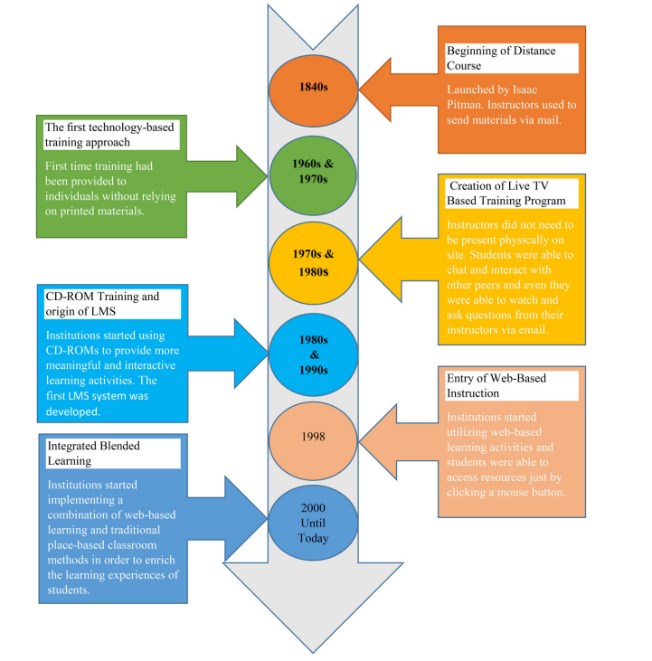 A popular educational strategy that mixes traditional face-to-face instruction with online learning activities is known as blended learning (Kang & Kim, 2021). It provides students with greater flexibility, personalization, engagement, collaboration, and better results (Kang & Kim, 2021; Bordoloi et al., 2021). The COVID-19 epidemic, which primarily affected 2020 to 2021, boosted the spread of blended learning throughout the world, including Malaysia. To ensure continuity in the delivery of education, educators and institutions have investigated blended learning models in light of the necessity for remote learning and social distancing measures.

Figure 1: Evolution of Blended Learning (Source: Singh et al., 2021)

In Malaysia, a lot of institutions and colleges have included blended learning strategies into their curricula. This combines in-person instruction with online lectures, virtual discussions, and interactive online exercises. The introduction of a hybrid, flexible learning system by Malaysia's Minister of Higher Education, Datuk Seri Mohamed Khaled Nordin, on June 4, 2023, is a sign that the country's educational system will gradually transition to a blended learning system with mandatory attendance only in the first and final years. Blended learning offers individualised teaching possibilities and enables students to learn at their own pace (Xu et al., 2021). To fully comprehend the variables determining the ideal ratio of online and face-to-face training in blended learning environments, more research is still required (Kang & Kim, 2016).

While there are studies that have looked into how blended learning affects learning outcomes, the majority of them are context-specific and concentrated on particular demographics or disciplines (Kang & Kim, 2021). In order to improve instructional practises, it is crucial to investigate the efficacy of blended learning in diverse educational contexts (Müller & Mildenberger, 2021). Furthermore, prior research on blended learning has mostly concentrated on student behaviour and patterns, neglecting other essential elements including the learning context, teachers' behaviour, and access to learning materials (Xu et al., 2021). Designing and implementing successful blended learning models requires an understanding of these aspects (Xu et al., 2021).

Additionally, despite the positive outcomes of blended learning, there remain gaps in the body of research. For instance, the generalizability of the findings to other contexts was constrained by Kang and Kim's (2021) study's exclusive emphasis on nursing students enrolled in a public healthcare school. Furthermore, their study's two-year gap between the experimental and control groups may have caused some outcomes fluctuation. Similar to this, Xu et al. (2021) ignored the wider range of significant elements by analysing only a small subset of characteristics that influence blended learning performance. Thus, for instructional designers and educators to make well-informed decisions, it is crucial to have a thorough awareness of all the variables that affect the ideal blend.

The goal of this project is to develop blended learning strategies in light of these research gaps. In addition to exploring the effects of various instructional ratios on student engagement and learning outcomes, it aims to shed light on the variables influencing the ideal blend of face-to-face and online instruction and offer evidence-based suggestions for developing and implementing blended learning models. This research attempts to offer insights into the components that lead to an effective blend in blended learning environments by undertaking a thorough analysis of learner profiles, instructional goals, subject content, and technological considerations.

In conclusion, this study will fill in information gaps, improve teaching strategies, and help create powerful blended learning models that encourage student involvement and improve learning outcomes. Teachers can design meaningful learning experiences that meet the varying requirements of students in various educational environments by identifying the ideal combination of online and face-to-face training.

**Section 1**

**Problem Statement**

Blended learning is now recognised as a potential method of instruction that mixes online and in-person classroom instruction to give students flexibility and improve their learning opportunities (Bordoloi et al., 2021). Even though numerous components of blended learning have been studied by previous research, there are still substantial gaps that must be filled in order to effectively design and execute blended learning models. For instance, Bordoloi et al. (2021) emphasise the need of comprehending educators' and students' attitudes towards online and blended learning in the context of the COVID-19 pandemic in India. However, only a small amount of research thoroughly examines the variables determining the ideal ratio of online and face-to-face learning settings in Malaysian higher education (Bordoloi et al., 2021). Given the differences in geographical, demographic, and background characteristics of Malaysian students compared to other foreign studies, it is necessary to understand the main factors influencing the optimal blend of online and face-to-face instruction in blended learning systems in Malaysian higher education to enable comparison with students from other countries in this context.

Investigating the effects of various instructional ratios on student engagement and learning outcomes is essential for designing effective blended learning models. In their research study, Heilporn et al. (2021) looked at the methods teachers use to encourage student involvement in blended learning in higher education. The study included a thorough analysis of teachers' tactics in this area, outlining tactics connected to synchronous or asynchronous modes as necessary. To further understand the effects of various ratios of online and face-to-face instruction on student engagement and learning outcomes in diverse educational situations, more research is required (Heilporn et al., 2021). Additionally, the effect of blended learning, namely the flipped classroom with team-based learning, on learning outcomes in a healthcare education course was another area of focus for Kang and Kim (2021). However, more investigation is required to determine the impacts of various instructional strategies and ratios on learning outcomes across a range of academic fields and institutional contexts (Kang & Kim, 2021).

Designing adaptable blended learning models requires a thorough understanding of the efficiency of substituting online learning for in-person instruction. A comprehensive review carried out by Müller and Mildenberger (2021) provided insight into this issue. The efficiency of this strategy and its implications for flexible learning in higher education, however, need additional investigation (Müller & Mildenberger, 2021). Additionally, Singh et al.'s (2021) discussion of blended learning in the context of a post-pandemic educational environment offered insights into its potential. However, further research is required to examine the best practises, techniques, and models for integrating face-to-face and online instruction in a variety of educational contexts (Singh et al., 2021).

This study seeks to fill in these research holes and add to the body of knowledge on blended learning. Beyond the pandemic context, it aims to examine how students and teachers view online and blended learning, comprehend the factors that influence the best combination of online and face-to-face instruction, look into the effects of various instructional ratios on student engagement and learning outcomes, and offer evidence-based recommendations for developing and implementing successful blended learning models. This research aims to fill the gaps in the literature and offer beneficial insights for educators, instructional designers, and policymakers by integrating and synthesising the findings from the studies carried out by Bordoloi et al. (2021), Heilporn et al. (2021), Kang and Kim (2021), Müller and Mildenberger (2021), and Singh et al. (2021).

By offering a thorough analysis of the variables influencing the ideal blend, the effects of various instructional ratios on student engagement and learning outcomes, and evidence-based recommendations for efficient blended learning models, this research will, in the end, contribute to the ongoing conversation on blended learning. This study aims to advance our understanding of blended learning and provide practical insights that can guide instructional practises, improve student learning experiences, and improve educational outcomes by addressing the identified research gaps and taking into account the distinctive characteristics of the research context.

**Section 2**

**Research Question**

1. What are the main factors influencing the optimal blend of online and face-to-face instruction in blended learning environments in Malaysia higher educations?
2. How do different ratios of online and face-to-face instruction affect student engagement and learning outcomes in blended learning for Malaysia higher educations?
3. What are the evidence-based recommendations can be provided on designing and implementing effective blended learning models?

**Section 3**

**Research Objective**

1. Identify the main factors influencing the optimal blend of online and face-to-face instruction in blended learning environments in Malaysia higher educations.
2. To investigate the effects of different ratios of online and face-to-face instruction on student engagement and learning outcomes in blended learning in Malaysia higher educations.
3. To provide evidence-based recommendations on designing and implementing effective blended learning models.

**Section 4**

**Scope and Contribution**

The research scope encompasses both qualitative and quantitative methods. Qualitative data will be collected through interviews and focus group discussions with educators and administrators experienced in blended learning. These qualitative insights will identify key factors influencing the blend, such as learner characteristics, instructional goals, technological considerations, and pedagogical strategies. The qualitative phase will provide a foundation for the subsequent quantitative phase.

The quantitative phase will involve administering a survey questionnaire to a diverse sample of Malaysia higher education students with different backgrounds, faculties, courses and demographic. The survey data will be analyzed using descriptive statistics, correlation analysis, and regression analysis to examine the relationships between instructional ratios, student engagement levels, and learning outcomes. This analysis will determine the impact of different blends on student engagement and learning outcomes.

The contribution of this research lies in providing a comprehensive understanding of the optimal blend of online and face-to-face instruction in blended learning environments. By integrating qualitative and quantitative findings, the study aims to fill the existing knowledge gaps and offer valuable insights into instructional design decisions. The research outcomes will inform educators and policymakers in designing and implementing effective blended learning models that maximize student engagement and foster positive learning outcomes.

Specifically, the contributions of this research are as follows:

1. Knowledge Contribution: This study addresses the existing knowledge gap by investigating the factors influencing the optimal blend of online and face-to-face instruction in blended learning environments. By exploring these factors, the research contributes to a deeper understanding of the design and implementation of effective blended learning models.
2. Practical Contribution: The findings of this research will provide evidence-based recommendations for educators and policymakers involved in blended learning. These recommendations will guide instructional practices and help in the development of effective blended learning models that cater to the diverse needs of Malaysia higher education students.
3. Pedagogical Contribution: By examining the effects of different instructional ratios on student engagement and learning outcomes, this research contributes to the pedagogical understanding of blended learning. The insights gained will inform instructional strategies and enhance the overall learning experiences of Malaysia higher education students.
4. Contextual Contribution: This research focuses specifically on Malaysia higher education students, providing insights into the optimal blend of online and face-to-face instruction in the local educational context. The findings will be relevant and applicable to the university's blended learning initiatives, supporting their efforts to improve student engagement and learning outcomes.

In conclusion, this research project aims to contribute to the field of blended learning by addressing the existing knowledge gap and offering valuable insights into instructional design decisions. The study's scope encompasses investigating the factors influencing the blend, examining the effects of different instructional ratios on student engagement and learning outcomes, and providing evidence-based recommendations for designing and implementing effective blended learning models. Through its contributions, this research seeks to enhance instructional practices and promote student success in blended learning environments at the Malaysia higher education.

**Reference**

Bordoloi, R., Das, P., & Das, K. (2021). Perception towards online/blended learning at the time of Covid-19 pandemic: an academic analytics in the Indian context. *Asian Association of Open Universities Journal*, *ahead-of-print*(ahead-of-print).

Heilporn, G., Lakhal, S., & Bélisle, M. (2021). An examination of teachers’ strategies to foster student engagement in blended learning in higher education. *International Journal of Educational Technology in Higher Education*, *18*(1). https://doi.org/10.1186/s41239-021-00260-3

Kang, H. Y., & Kim, H. R. (2021). Impact of blended learning on learning outcomes in the public healthcare education course: a review of flipped classroom with team-based learning. *BMC Medical Education*, *21*(1). https://doi.org/10.1186/s12909-021-02508-y

Müller, C., & Mildenberger, T. (2021). Facilitating Flexible Learning by Replacing Classroom Time With an Online Learning Environment: A Systematic Review of Blended Learning in Higher Education. *Educational Research Review*, *34*, 100394.

Singh, J., Steele, K., & Singh, L. (2021). Combining the best of online and face-to-face learning: Hybrid and blended learning approach for COVID-19, post vaccine, & post-pandemic world. *Journal of Educational Technology Systems*, *50*(2).

Xu, Z., Yuan, H., & Liu, Q. (2021). Student Performance Prediction Based on Blended Learning. *IEEE Transactions on Education*, *64*(1), 66–73.